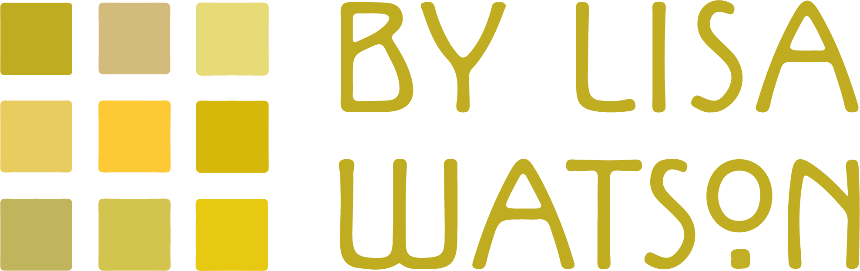

Started in 2013 with a range of Harris Tweed Patchwork Quilts By Lisa Watson is a authentically British collection of cushions, blankets & more for your home.
A passion for celebrating British textile heritage has led to yearly additions of quality textile home decor from one of a kind handmade Harris Tweed cushions (Every one of my cushions is distinctive, made up of a combination of genuine Harris Tweed and backed with either my Folklore Fabric or British velvets) to blankets inspired by Fair Isle (knitted from British wool in Leicest, the home of English knitting) and all are perfect for adding extra warmth to the bedroom or draped on a sofa to bring eye catching interest all year round. My full collection of quilts, cushions & more can be viewed online at quiltsbylisawatson.co.uk
Thios year woven blankets in new colourways will be added to the By Lisa Watson collection in three designs; Houndstooth; Fair Isle and Tumbling Block, all inspired by quintessentially British motifs which by playing with the pattern creates a contemporary adaption of these classically British designs.

As with all off my By Lisa Watson collections, these blankets are made in Britain, will compliment any interior scheme and whose design and colours are a real tonic to counteract dreary days.

-Ends-

Editor’s Notes:
To request high res images or further information, please contact Lisa Watson on 017719359864/ lisawatso@outlook.com
Image Gallery:
(Please get in touch to see the full range)

