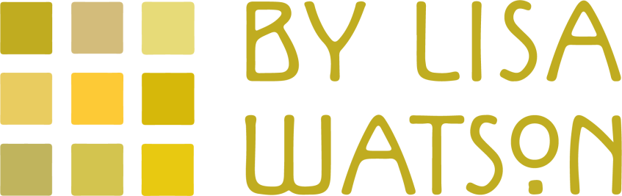 Price List
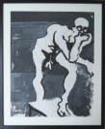 B&W male standing nude – gouache – 88x73cm £385
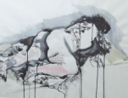 Tattooed lady - watercolour & pen&ink – 85x69cm £385
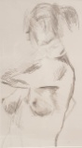 Hand on neck torso study - graphite pencil –76x53cm £250
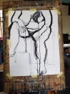 Full frontal nude – B&W ink – 96x66cm £350
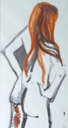 Redhead with hands on hips – pen&ink – 95x58cm £325
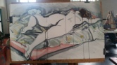 Reclining diagonal nude – watercolour – 99x73cm £385
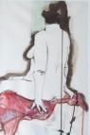 Nude sitting on a red scarf - watercolour,pen&ink -74x56 £325
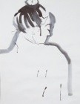 Japanese inspired head study – B&W ink – 66x53cm £275
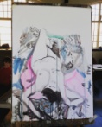 Nude reclining on patterns – coloured inks – 87x74cm £385
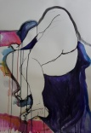 Reclining BB nude – coloured inks – 96x76cm £385
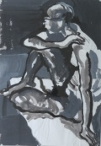 Seated Male Nude – gouache – 92x72cm £385
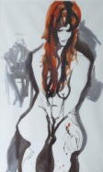 Redhead Looking Down – pen & ink – 97x72cm £325
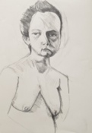 Nonplussed Portrait - graphite pencil – 52x39 cm £250
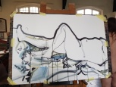 Reclining Nude with bent - inks – 97x76cm - £325
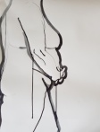 Torso with Hands Clasped - B&W ink - 71x58cm £250
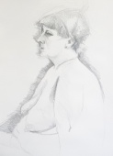 Just Staring portrait - pencil study – 75x 63cm £250
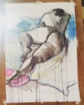 Nude Lying Diagonally on Blue Fabric - ink – 83x66cm £385
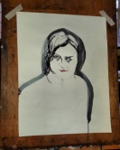 Red Lips Portrait - B&W ink – 71x58cm £275
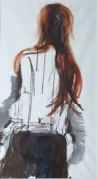 Red Head Back View - pen&ink - 98x60cm - £325

https://www.quiltsbylisawatson.co.uk/original-artworks/

