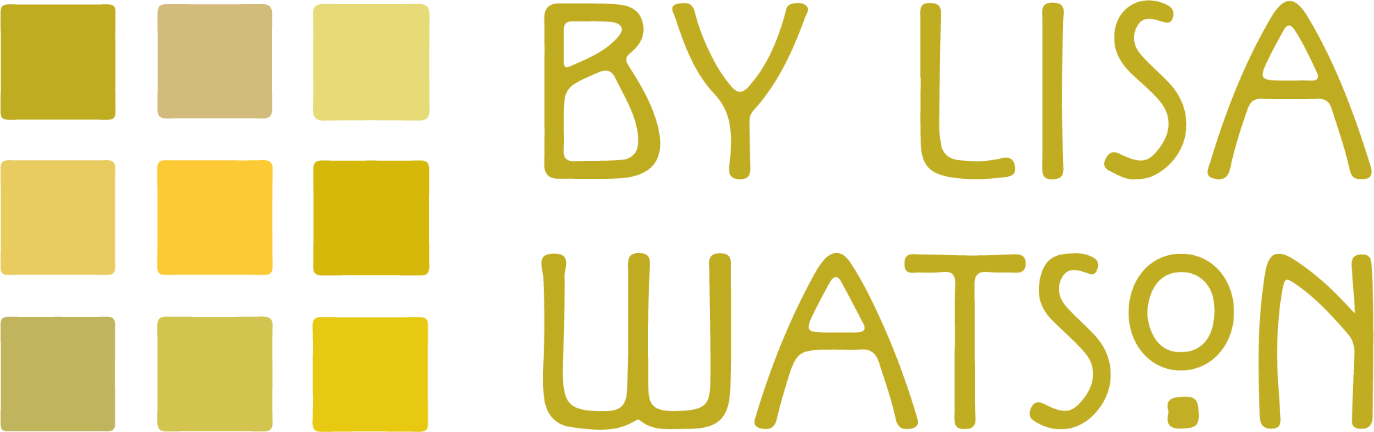

By Lisa Watson is a authentically British collection of quilts, cushions & more for your home.
A passion for celebrating British textile heritage has led to new additions of quality textile home decor from one of a kind handmade Harris Tweed cushions to blankets inspired by Fair Isle knitted from British wool and all are perfect for adding extra warmth to the bedroom or draped on a sofa to bring eye catching interest all year round. My full collection of quilts, cushions & more can be viewed online at quiltsbylisawatson.co.uk

Back in 2020 are even more delicious colourways and weaves of my Folklore Fabric cushions, backed in British velvets and which are available in four sizes; an impressive 70x70cm floor cushions, useful 50x50cm square cushion, practical 60x30cm rectangle cushion and a cute 45x25 mini cushion. Folklore Fabric is unique to my shop and is an exciting collaboration between myself, as the designer, Richard MR Smith, a master weaver and the talented folk at Weisters Mill in Darwen, Lancashire.

You can also choose one of a kind 100% British made Harris Tweed Patchwork cushions. NEW for 2020 are mini cushions, which at 45x25cm are perfect for a tub chair, to use in the small of your back, or as a handy travel pillow. Every one of my cushions is distinctive, made up from a combination of Harris Tweeds and backed with either Folklore Fabrics or British velvets.

As with all off my By Lisa Watson collection, these cushions are handmade in Britain, will compliment any interior scheme and are a real colour tonic to counteract dreary days.

-Ends-

Editor’s Notes:
To request high res images or further information, please contact Lisa Watson on 017719359864/ lisawatso@outlook.com
Image Gallery:
(Please get in touch to see the full range)

