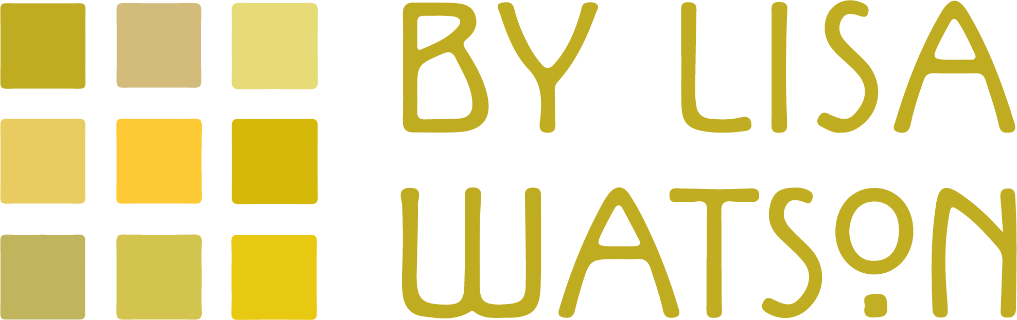

Started in 2013 with a range of Harris Tweed Patchwork Quilts By Lisa Watson is a authentically British collection of cushions, blankets & more for your home.
A passion for celebrating British textile heritage has led to yearly additions of quality textile home decor from one of a kind handmade Harris Tweed cushions (Every one of my cushions is distinctive, made up of a combination of genuine Harris Tweed and backed with either my Folklore Fabric or British velvets) to blankets inspired by Fair Isle (knitted from British wool in Leicester, the home of English knitting) and all are perfect for adding extra warmth to the bedroom or draped on a sofa to bring eye catching interest all year round. My full collection of quilts, cushions & more can be viewed online at quiltsbylisawatson.co.uk
This year new Made in GB blankets will be added to the By Lisa Watson collection, these
latest additions are also made in Britain, will also compliment any interior scheme and whose design and colours are also a real tonic to counteract dreary days.

-Ends-

Editor’s Notes:
To request high res images or further information, please contact Lisa Watson on 017719359864/ lisawatso@outlook.com
Image Gallery:
(Please get in touch to see the full range)

